**Experiment - 1.5(b)**

**Student Name: Milan Sharma UID: 23MAI10003**

**Branch: ME – CSE - AIML Section/Group: MAI – 1 (A)**

**Semester: 1st Date of Performance: 06 Sep 2023**

**Subject Name: Python Programming Subject Code: 23 CSH 623**

1. **Aim of the Experiment :**

## Write a Python program to print the largest element in an array

1. **Objective of the Experiment :**

To print the largest element in an array

1. **Algorithm/ Steps for Experiment**

**STEP 1:** Declare and initialize an array.

**STEP 2:** Store first element in variable max.

**STEP 3:** Loop through the array from 0 to length of the array and compare the value of max with elements of the array.

**STEP 4:** If any element is greater than max, max will hold the value of that element.

**STEP 5:** At last, max will hold the largest element in the array.

1. **Code for Experiment :**

arr = [25, 11, 7, 75, 56];

max = arr[0];

for i in range(0, len(arr)):

if(arr[i] > max):

max = arr[i];

print("Largest element present in given array: " + str(max));

1. **Result/Output :**

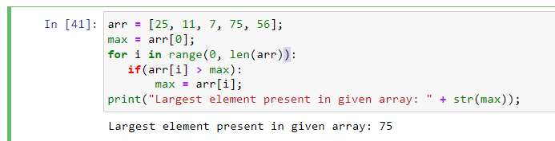

**Learning outcomes (What I have learnt):**

1. Learnt different operations performed on array like largest elements in the array.

**Evaluation Grid (To be created as per the SOP and Assessment guidelines by the faculty):**

|  |  |  |  |
| --- | --- | --- | --- |
| **Sr. No.** | **Parameters** | **Maximum Marks** | **Marks Obtained** |
| **1.** | **Student Performance**  **(Conduct of experiment)**  **Objectives/Outcomes.** | 12 |  |
| **2.** | **Viva Voce** | 10 |  |
| **3.** | **Submission of Work Sheet**  **(Record)** | 8 |  |